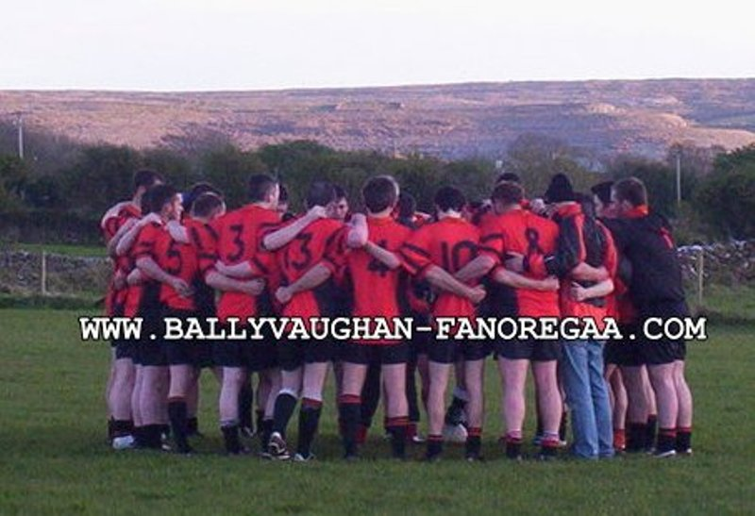

Ballyvaughan V Killmurry-Ibrickane in Ballyvaughan on Saturday 11th April 09.
Report Supplied By Gillian Bowie P.R.O Ballyvaughan / Fanore GAA Club.
1. James Callinan
2. Mark Walsh
3. Philip Monks
4. Kieran Casey
5. Mark O'Loughlin
6. Diarmuid Greene
7. Setanta Moran
8. Raymond Casey
9. James Hynes
10. Phelim Kyne
11. Killian Mahon
12. Kevin Carrucan
13. Jack Queally
14. Paul Mc Donagh
15. Tomas Francis
Subs :-
16. Damien McNamara for Paul Mc Donagh
18. John Linnane for Killian Mahon
19. Paul Darcy for Setanta Moran
23. John Martyn for Jack Queally
Ballyvaughan overcame Killmurry-Ibrickane in the Division 3 League on Saturday evening. An entertaining game played in Ballyvaughan on a score of 2:9 to 0:9.
The home side had the better of proceedings in the 1st half building up a 0:6 to 0:4 lead with points from Tomas Francis (3) Kevin Carrucan (1) Mark Walsh (1) and John Martyn (1).
Ballyvaughan kicked on in the 2nd half with goals coming from Tomas Francis and substitute Paul Darcy. This killed off a stubborn Killmurry-Ibrickane. Best on the day for Ballyvaughan were Mark Walsh, Phelim Kyne, Diarmuid Greene and Tomas Francis who scored 1:4 over the hour others to score points in the second half were Mark O'Loughlin, Phelim Kyne and John Martyn. Killmurry-Ibrickane had impressive performances from Pat Sexton, John Talty and Aidan (Horse) Maloney.

