Gearldine League Division 4 Football League 2012 Round 6
Venue: - Ballyvaughan Community Field
Referee: Pat Cosgrove Corofin

Pictures Supplied by Conor Mahon

Ballyvaughan 2:08
O’Callaghan’s Mills 1:10

A division 4 league relegation / survival showdown now awaits with Naomh Eoin on the 16th of June in Cross, after Ballyvaughan put a first back to back league victory together in nearly three years, May 2009 to be exact as a 1 point win and a draw was achieved in 2010 before relegation in 2011 from the Banner Cup to the Geraldine League division 4.

All at Ballyvaughan-Fanore GAA Club welcomed O’Callaghan’s Mills and their supporters to Ballyvaughan Community for the first time. An O’Callaghan’s Mills team came to the Burren with a panel of players 17 in total missing at least a dozen players due to other commitments mostly hurling (Pat Donnellan, Conor Cooney and Brian Donnellan) and Handball and injuries. While Ballyvaughan on the other hand only had 15 players available to them not for the first time this year they had found them self in this situation due to exams and injuries playing a big part of this of the squad that was available for the year 2012.

O’Callaghan’s Mills were the more dominant in the opening exchanges but Ballyvaughan did get the opening two scores to lead 2 to 0 in the first five minutes, The Mills then took over completely and a headline grabbing display from midfielder Conor Cooney his teams top scorer from play with 1:03, got his teams first and only goal late in the first half to leave the half time score 1:06 to 4 points, Pa McMahon came on for Paul Murphy in the 20th minute after he sustained a nasty ankle injury.

The headline grabbing display was switched totally on Ballyvaughan in the second half.
The winning scores might be chosen from two goals that were scored but this was definitely a team effort for the second 30 minutes.
Goal number one can only be described as a fluke, but a goal is a goal and this one definitely counted and brought Ballyvaughan right back in to contention, as Raymond Casey had an element of good fortune about this as he delivered the ball goal bound from about 30 ish or so yards, the ball dipped low in the small square and as the goalkeeper fumbled the ball it then staggered over the line in to the back of the Mills net.
For goal number 2 it was a touch class from Adrian Nilan, Sean McNamara also fisted over two points from play.

With a two point lead in the final 10 minutes Ballyvaughan packed the defense with all players with exception of Cathal Irwin and Killian Fahy behind the ball , The Mills attacked in waves but could have and should have took their points instead of going for goals. A breach of the discipline process saw Kieran Casey get his second yellow in the last ten minutes. Ballyvaughan survived the challenge with 14 men.

It was a thrilling finale as Ballyvaughan held their nerve and saw out the final challenges and secured the valuable league points

James Callinan
John Mooney Hynes
Damien Martyn
John Linnane
Sean McNamara
Kieran Casey
Mark Walsh
Jamie Hynes
Ray Casey
Killian Fahy
Kevin Carrucan
Cian Walsh
Damien McNamara
Adrian Nilan
Cathal Irwin

No subs

Ger Foran
David McMahon
Niall O'Donovan
Michael McGrath
Gerry Cooney
John Cooney
Kevin O'Callaghan
James Murphy
Conor Cooney
Mark Puter
Stevie Donnellan
Ian Donnellan
Paul Murphy
Eoin McGrath
Fergus O'Donovan

Subs
Pa McMahon for Paul Murphy (Inj) 20 mins
Eoin Kelly for Ian Donnellan

Scores:
Ballyvaughan / Fanore
Ray (1:00) play
Kevin Carrucan (0:02) Play
Jamie Hynes (0:02) Play
Sean McNamara (0:02) Play
Damien McNamara (0:02) Frees
Adrian Nilan (1:00) Play

O’Callaghan’s Mills
Fergus Donovan (0:03) 2 Play and 1 Free
Conor Cooney (1:03) Play
Ian Donnellan (0:01) Play
Eoin McGrath (0:01) Play
John Cooney (0:01) Play
Paul Murphy (0:01) Play

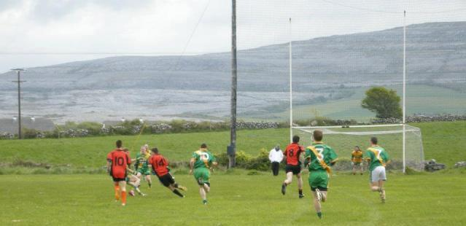

Adrian Nilan shows a touch of class while he works his way through a packed O’Callaghan’s Mills defense to score Ballyvaughan second goal.
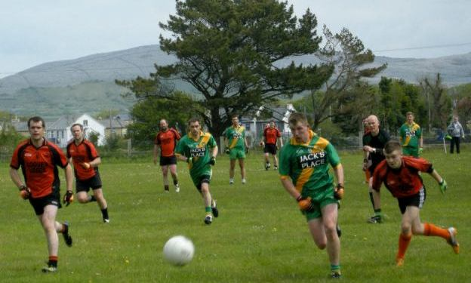

All eyes are on the ball !!!!!!!!!!!!!!!!!!!!!!!!!!!!!!!!!!!!!!

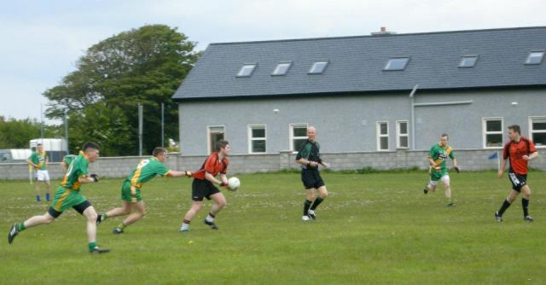

Testing the fabric on the jumper, Adrian Nilan awaits for the pass.
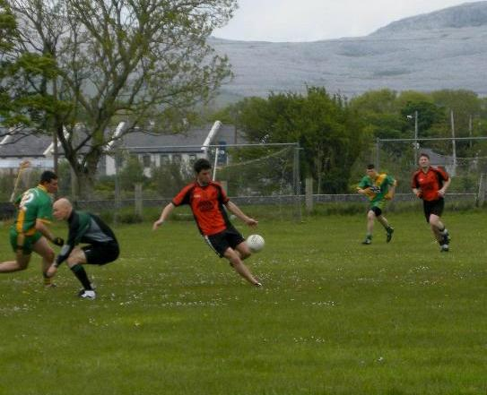

Cian Walsh launches another Ballyvaughan attack on the O’Callaghan’s Mills goal
His brother Mark looks on, Pat Cosgrave ducks down for cover.

